Your Paper's Title Starts Here: Please Center
use Helvetica (Arial) 14
FULL First Author^{1, a *}, FULL Second Author^{2,b} and FULL Last Author^{3,c}
¹Full address of first author, including country
²Full address of second author, including country
³List all distinct addresses in the same way
ªemail, ^{b}email, ^{c}email
* please mark the corresponding author with an asterisk

Extended Abstract

This template explains and demonstrates how to prepare your extended abstract for ICOG-ITA 2024. The extended abstract is prepared for the reviewers and the Scientific Committee to decide the suitability of the work for presentation at the conference and publication in the selected journal.
Authors are requested to submit the electronic form of an extended abstract via online submission at https://sites.google.com/ums.edu.my/icog-ita-2024.

The extended abstract should be written in English. The writing must be in MS Word format in single-spacing using 12 point of Times New Roman. Page settings are A4 format (21 x 29.7 cm or 8 x 11 inches), margin with bottom 1.5 cm (0.59 in) and top 2.5 cm (0.98 in), and right/left margins are 2 cm (0.78 in). Text paragraphs must be justified with no indentation. The length of the abstract is restricted to the maximum of TWO (2) pages. The extended abstract has to be concise and informative, and include the importance of the research, the problem to solve, the objective of the study, the methodology and the conclusions of the work. The extended abstract can contain a maximum of TWO (2) supporting figures or images. All figures or images should be centered, and caption in 11 point should be placed under the figure or image (see Figure 1). Pages should not be numbered.

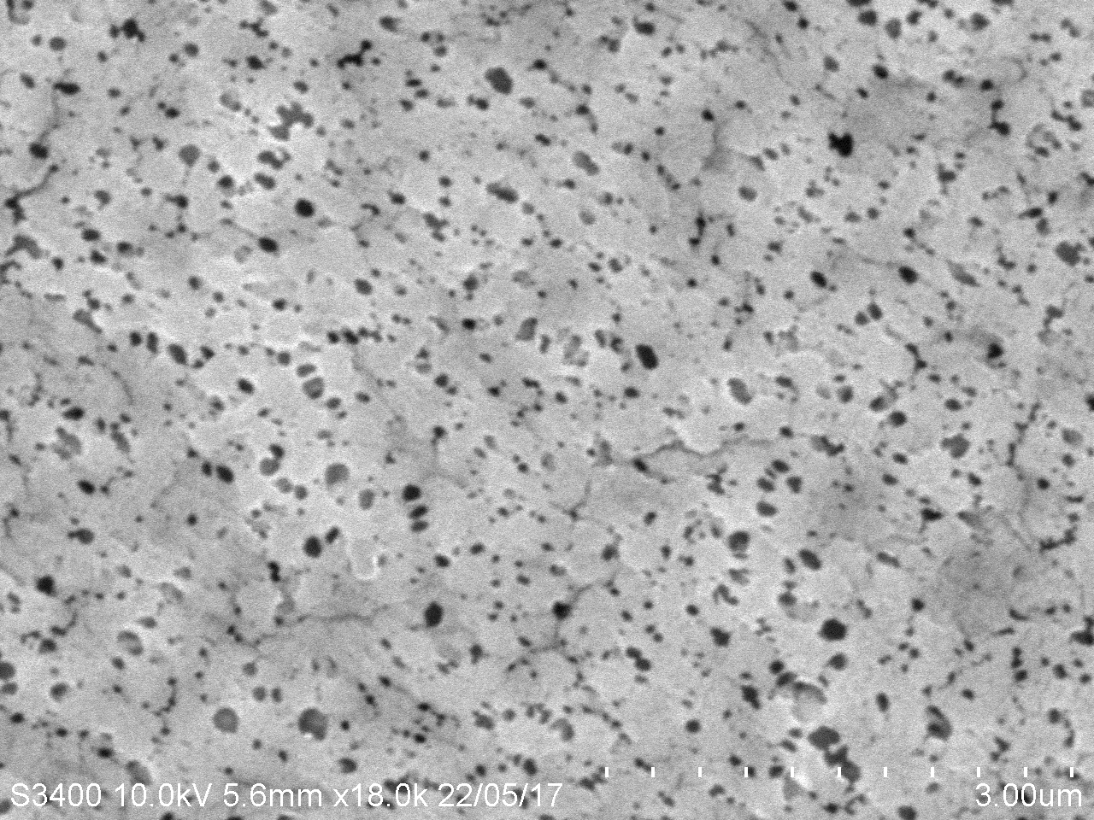
Figure 1: Surface morphology of membrane PES/AG/#1.

Acknowledgment of the research work should be included in the extended abstract and written in 11 point of Time New Roman.

References of the article should be included in the extended abstract and numbered consecutively using Arabic numerals in square brackets. The reference list should be in 11 point of Times New Roman, using the format given and justified (see References).

Keywords: Please provide 5 to 6 keywords separated by semicolon e.g. Sample; Conference; Abstract.

Acknowledgment
This study was supported by XXX.

References
[1] Chai MH, Tan BC, Lee CH. (2024) Freeze-casting bicomponent aerogel system. J Sep Filtr. 293: 121087.
[2] Issac DF, Eva JA (2024) Numericals for Computer Simulation. Publisher, NY.
[3] Ahmad, G. (2024) Separation Process Using Finite Element Method. PhD Thesis, University Chem. Eng. Dept., Lagos.

