“BOCAUE CIVIL REGISTRY DIGITAL SERVICES PLATFORM (BCR-DSP) WITH AI ASSISTED CHATBOT”

Rowell C. Santos¹, Ana Lizel B. Del Poso², Clarissa P. Vicente³, Ma. Pinky V. Reyes⁴, Marisse V. Presilda⁵, Danica M. Pablo⁶

¹College of Information Technology Education, Baliuag University, Philippines
²College of Information Technology Education, Baliuag University, Philippines
³College of Information Technology Education, Baliuag University, Philippines
⁴College of Information Technology Education, Baliuag University, Philippines
⁵College of Information Technology Education, Baliuag University, Philippines
⁶College of Information Technology Education, Baliuag University, Philippines

desire4god@gmail.com, analizeldelposo@baliuagu.edu.ph, clarissavicente@baliuagu.edu.ph, mapinkyreyes@baliuagu.edu.ph, marissepresilda@baliuagu.edu.ph, danicapablo@baliuagu.edu.ph

Abstract: The Civil Registrar Office of Bocaue Bulacan, relies on a manual queuing and transaction process, resulting in long waiting times, repetitive client visits, and inefficient service delivery. To address these challenges, the researchers developed BOCAUE Civil Registry Digital Services Platform (BCR-DSP) with AI Assisited Chatbot, a web-based information and queuing management system. Key features include online appointment scheduling, document requirement uploads, smart walk-in queue, and real-time email notifications. The system was developed using the Agile SDLC methodology, with technologies such as Vite React (frontend), NestJS (backend), MySQL (database), MinIO (S3 Compatible Object Storage API), and Render (deployment). To evaluate BCR-DSP, ISO/IEC 25010 Software Product Quality Model and the Technology Acceptance Model (TAM) was chosen, measuring functionality and user satisfaction. Respondents included 1 system administrator, 6 municipal staffs, 10 IT professionals, and 70 citizen users, selected through stratified and random sampling. Data collection was conducted through Google Forms surveys, interviews, and direct observations. The system earned Excellent ratings in functional suitability, performance efficiency, compatibility, usability, reliability, and maintainability confirming its stability, responsiveness, and adaptability to evolving needs. Overall, the system meets all the intended functional, quality standards, was well accepted across user groups and efficient tool for enhancing public service delivery in the municipal civil registrar of Bocaue, Bulacan.

Keywords: Civil Registry Digitalization, Smart Queuing System, AI Assistant Chatbot.

- INTRODUCTION
As Bocaue continued to grow in population and urban development, the demand for efficient public services likewise increased. At present, the Municipal Civil Registrar’s Office of Bocaue still relies on a manual transaction and queuing system, wherein citizens obtain queue numbers at the counter and wait for their numbers to be announced. This traditional approach often results in delays, particularly when citizens fail to hear their queue numbers, leading to missed turns, repeated calls, and prolonged waiting times.

Furthermore, the office frequently encounters citizens returning multiple times due to incomplete or invalid documentary requirements, as well as repeatedly answering commonly asked questions regarding civil registration processes. These situations contribute to congestion, longer queues, and additional workload for office personnel. According to the office administrator, these challenges emphasize the pressing need for a digitalized transaction management system.

The BOCAUE Civil Registry Digital Services Platform (BCR-DSP) aims to streamline civil registry services by integrating features such as document requirement guidelines, appointment scheduling system, online application processing, and frequently asked questions module. Through digitalization, the system seeks to reduce delays, minimize repeat visits, and enhance overall service delivery efficiency within the office.

- METHODOLOGY
To develop a quality system, the researchers used the quantitative method to create a clear and descriptive approach to the study and to conduct a numerical evaluation of the developed system. The system was assessed using the ISO/IEC 25010 Software Product Quality Model to measure software quality attributes such as functionality, usability, reliability, performance efficiency, maintainability, and security. In addition, the Technology Acceptance Model (TAM) was applied to evaluate user acceptance based on perceived usefulness and ease of use.

2.1 AGILE MODEL
The researchers chose the Agile model of development, as it was helpful in the continuous assessment of each module (iteration). Any changes were communicated to the responsible developers, allowing them to respond quickly during the development process. Furthermore, adopting the Agile model enabled the developers to maintain ongoing communication with the project stakeholders to determine if any adjustments to the project were necessary.
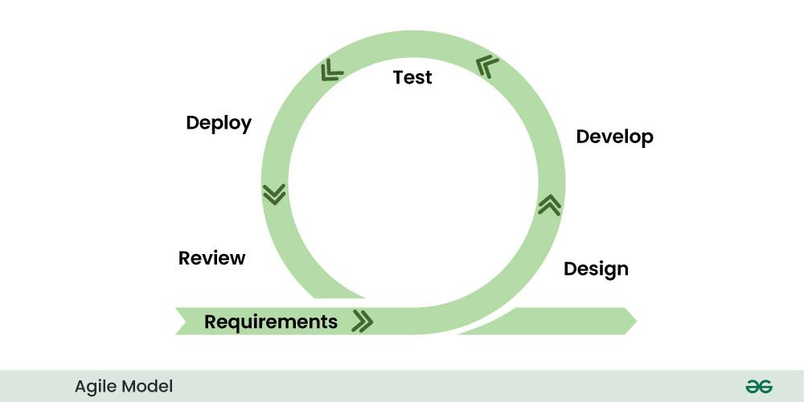

Figure 1: Agile Model

The Agile method is an iterative methodology where the team can reflect and look back to see if there was anything that could be improved so that they can adjust their strategy for the next sprint. Agile also prioritizes team collaboration, and collaboration with the client so that they can guide where the software should go.

- RESULTS & DISCUSSION
The developed BOCAUE Civil Registry Digital Services Platform (BCR-DSP) successfully automated appointment scheduling, document submission, queue number generation, and real-time notifications for citizens of Bocaue, Bulacan. The system integrated cloud-based storage, queue monitoring, role-based authentication, and automated email notifications to improve transaction efficiency and accessibility. The following tables and figures present the major findings and explain how the system addressed the problems identified in the study.

Table 1: Distribution of Respondents

Respondent Group | Number of Respondents
System Administrator | 1
Municipal Staff | 6
IT Professionals | 10
End Users (Citizens of Bocaue) | 70

Table 1 presents the distribution of respondents who participated in the evaluation of the BOCAUE Civil Registry Digital Services Platform (BCR-DSP). The majority of respondents were citizen-users from Bocaue, Bulacan, with a total of 70 respondents. This ensured that the study gathered sufficient feedback from the actual users of the system. Additionally, 10 IT professionals participated in evaluating the technical quality of the platform based on ISO/IEC 25010 standards, while municipal staff and system administrators evaluated the usability and operational functionality of the system. The inclusion of different respondent groups provided balanced feedback from both technical evaluators and end-users.

3.1 ISO/IEC 25010 Software Quality Evaluation
Table 2 presents the summary of ISO/IEC 25010 evaluation results as assessed by IT professionals. Functional Suitability obtained the highest rating with an average mean of 3.70 (Excellent), confirming that the system covers all specified tasks and provides accurate outputs. Maintainability scored 3.42 (Excellent), reflecting the system’s modular design and ease of modification. Performance Efficiency achieved 3.43 (Excellent), demonstrating that the system meets response time, throughput, and resource utilization requirements. Reliability and Portability both scored 3.40 (Excellent), indicating stable operations and strong adaptability across different environments. Compatibility earned 3.30 (Excellent), while Usability scored 3.28 (Excellent), reflecting a user-friendly interface and broad accessibility. Security received a Very Good rating (mean = 3.10), highlighting the need for enhanced access controls and audit logging as future improvements.

Table 2. Summary of ISO/IEC 25010 Evaluation Results

Quality Characteristic | Average Mean | Interpretation
Functional Suitability | 3.70 | Excellent
Performance Efficiency | 3.43 | Excellent
Maintainability | 3.42 | Excellent
Reliability | 3.40 | Excellent
Portability | 3.40 | Excellent
Compatibility | 3.30 | Excellent
Usability | 3.28 | Excellent
Security | 3.10 | Very Good

3.2 Technology Acceptance Model (TAM) Evaluation Results
Table 3 and Figure 2 presents the Technology Acceptance Model (TAM) evaluation results gathered from users of the system. The respondents strongly agreed that the system supports timely and accurate processing of services with a mean score of 3.28. This indicates that the platform effectively streamlined transaction processing and improved the efficiency of municipal services. The respondents also strongly agreed that the system is accessible and operational whenever needed, with a mean score of 3.27, demonstrating the reliability and accessibility of the web-based platform.

Table 3: Technology Acceptance Model (TAM) Evaluation Results

Evaluation Criteria | Mean | Interpretation
Helps accomplish transactions more quickly | 3.18 | Agree
Reduces time spent in long queues | 3.14 | Agree
Supports timely and accurate processing of services | 3.28 | Strongly Agree
System is accessible and operational whenever needed | 3.27 | Strongly Agree
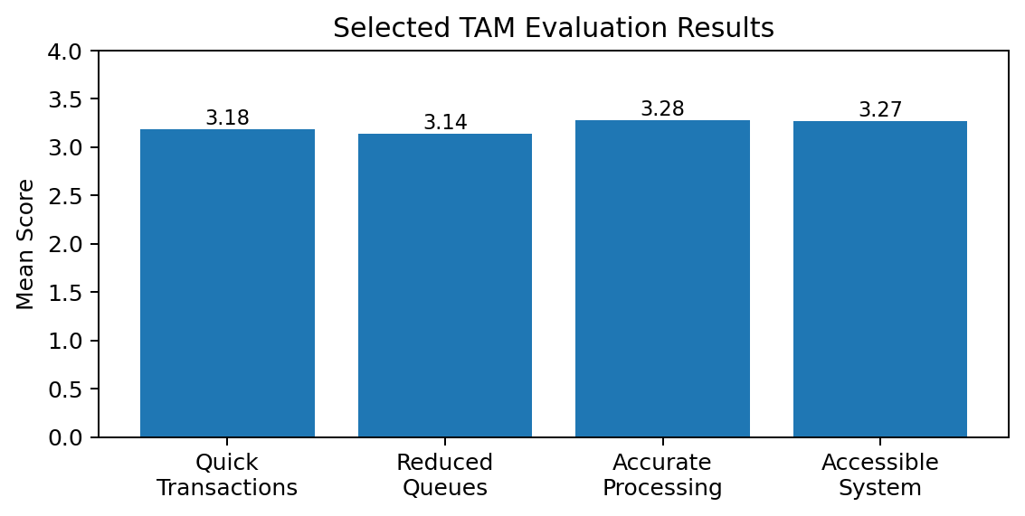
Figure 2. Graphical Presentation of TAM Evaluation Results

- CONCLUSION
Overall, the system meets all the intended functional and quality standards, was well accepted across user groups and served as an efficient tool for enhancing public service delivery in the Municipal Civil Registrar Office of Bocaue, Bulacan. The implementation of digital queuing, appointment scheduling, and cloud-based services significantly improved transaction efficiency, reduced waiting time, and enhanced citizen satisfaction.

ACKNOWLEDGEMENT

The researchers would like to express their sincere gratitude to the Municipal Civil Registrar Office of Bocaue, Bulacan, Baliuag University, the IT professionals, municipal staff, and citizen respondents who contributed to the successful completion of this study.

REFERENCES
Holdsworth, J., & Kosinski, M. (2024, September). Data governance. IBM. https://www.ibm.com/topics/data-governance

Imus, J. K. (2018). Barangay management information system (BMIS) for cities and municipalities in the Philippines. International Journal of Computer Applications, 180(19).

Khalid, S. A., & Lavilles, R. Q. (2019). Maturity assessment of local e-government websites in the Philippines. Procedia Computer Science, 161, 99–106.

Lallana, E. C., Pascual, P. J., Nakpil, K. B., & Recio, B. (2022, April). E-government in the Philippines: Benchmarking against global best practices. Digital Philippines. https://www.unapcict.org/sites/default/files/2019-01/e-Government%20in%20the%20Philippines%20-%20Benchmarking%20Against%20Global%20Best%20Practices.pdf

Laoyan, S. (2024, February 2). What is Agile methodology? (A beginner’s guide). Asana. https://asana.com/resources/agile-methodology

Marquez, C. (2020, August 30). LTO boosts automated monitoring of drivers’ violations. INQUIRER.NET. https://newsinfo.inquirer.net/1328847/lto-boosts-automated-monitoring-of-drivers-violations

Ona, S. (2019, October). E-government and interoperability initiatives in the Philippines: New directions, challenges and opportunities. ResearchGate. https://www.researchgate.net/publication/344199282

Ravšelj, D., Umek, L., Todorovski, L., & Aristovnik, A. (2022, April 21). A review of digital era governance research in the first two decades: A bibliometric study. Future Internet, 14(5). https://www.mdpi.com/1999-5903/14/5/126

Sugito, A., Prahutama, D., Ispriyanti, & Mustafid. (2021, June). Determination of non-poison queue system of distribution in the public service sector (Case study: Semarang city population and civil registry office). ResearchGate. https://www.researchgate.net/publication/353249303

Tapangan, E. (2021, September 1). Digital transformation for efficiency and resiliency in civil registration. Cagayan de Oro, Philippines.

Umali, L. (2021, December). Re-imagining government data in the Philippines. Medium. https://likas-umali.medium.com/re-imagining-government-data-in-the-philippines-835283a26b98

United Nations. (2022). UN E-Government Survey 2022. United Nations.
Van Dijk, J. A. (2019). The digital divide. ResearchGate. https://www.researchgate.net/publication/336775102_The_Digital_Divide

