EXTENDED ABSTRACT TITLE (not exceed 15 words)
(TIMES NEW ROMAN, 14 FONT SIZE, BOLD, ALL CAPS, CENTERED)

First Author¹, Second Author² and Third Author *³ (12 font size, Bold)

¹ Authors’ Department, Institute, Organisation, Country (11 font size)
² Authors’ Department, Institute, Organisation, Country (11 font size)
³ Authors’ Department, Institute, Organisation, Country (11 font size)
* Corresponding author email@ums.edu.my

Abstract: Abstract should be written with 11 font size, Times New Roman, justified, single line spacing. The abstract should be concise and should contain no more than 250 words. Problem statement, objectives, methods and findings are summarized in this section

Keywords: This section should contain maximum 5 words separated by commas.

- INTRODUCTION (Title Times New Roman, 12 font size, bold).
This format is to be used for submission of extended abstract that will be published in the Proceedings of the Asian Lifelong Learning Conference (ASAIHL 2026). The extended abstract maximum length is 3-5 pages including figure, table and references, written in English. It should be submitted in electronic form (MS-Word) via UPC link, with the name of the presenting author underlined. The incorrect formats may result in your abstract being returned to you by e-mail.

In this section, current literature regarding the work subject should be examined and the differences of the said work from the past, similar works should be presented clearly.

A digital version of the proceeding with ISSN number will be published in the seminar website. After the conference, selected submission will be invited to be extended into full papers for publishing in SCOPUS indexed journals, with additional fees (if accepted). To note, the final decision on the journal will be based on the reviewer’s comments and the SCOPUS journal.

- METHODOLOGY
The methodology must be clearly stated and described in sufficient detail or with sufficient references. The author shall explain the research question, describe the research framework, and the methods applied in detail. It should be furthermore highlighted why the research question is relevant to theory and practice, and why the chosen method(s) are suited for the problem.

  - Subtitle
First degree titles (2.) should be written left aligned, all caps and bold. Second and 3rd degree subtitles (2.1, 2.1.1) should be written left aligned, bold and with title case. A blank line should be placed between the paragraphs and there should not be any paragraph indentation.

- RESULTS & DISCUSSION
Presentation of the result obtained. If possible, use descriptive figures or tables rather than explain in text. Do not discuss or interpret the results at this stage. Discuss the results. Put your results in perspective by comparing to other studies or generally accepted knowledge in the field. Criticize your own method and results, for example, with respect to the simplifications made.

3.1 Subtitles
Supporting figures, tables and images may be included. All the tables, images and figures should be centered. Figures and images should be numbered and figure captions should be placed under the figure or image. Please see Figure 1 for an example. The tables should also be numbered and the table caption should be placed at the top. Please see Table 1 for an example.

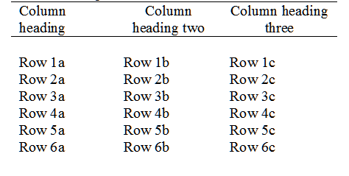
Table 1: Example Table

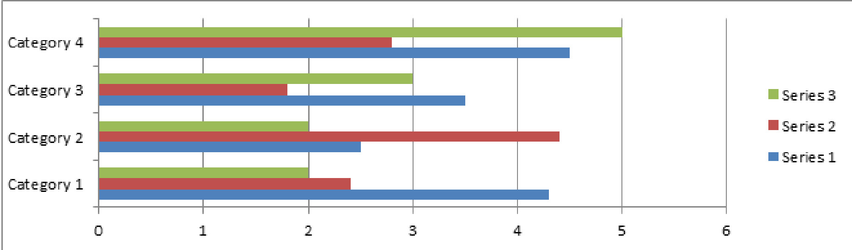

Figure 1. Example graph for the extended abstract.

- CONCLUSION
Please conclude your work incorporating your most important finding as well as future works (3-4 lines).

ACKNOWLEDGEMENT

Please acknowledge your research grant, organization, scholarship (where relevant).

REFERENCES
References should be prepared in APA 7th Edition style as shown in example below:

Common Reference Templates

1. Journal Articles
Template: Author, A. A., & Author, B. B. (Year). Title of the article. Title of the Periodical, Volume(Issue), Pages. https://doi.org/xxxx
- Example: Miller, J. R. (2022). The physics of acoustic resonance. Journal of Sound Studies, 15(2), 102–115. https://doi.org/10.1037/rev0000123

2. Books (Whole)
Template: Author, A. A. (Year). Title of the work. Publisher.
- Example: Walker, J. (2020). Fundamentals of physics (11th ed.). Wiley.

3. Edited Book Chapter
Template: Author, A. A. (Year). Title of the chapter. In E. E. Editor (Ed.), Title of the book (pp. xx–xx). Publisher.
- Example: Thompson, S. (2019). Wave mechanics. In R. Lee (Ed.), Advanced University Physics (pp. 45–67). Oxford University Press.

4. Webpages on a Website
Template: Author, A. A. (Year, Month Day). Title of the page. Site Name. URL
- Example: National Weather Service. (2023, June 10). Thunderstorm safety and science. NOAA. https://www.weather.gov/safety/lightning

